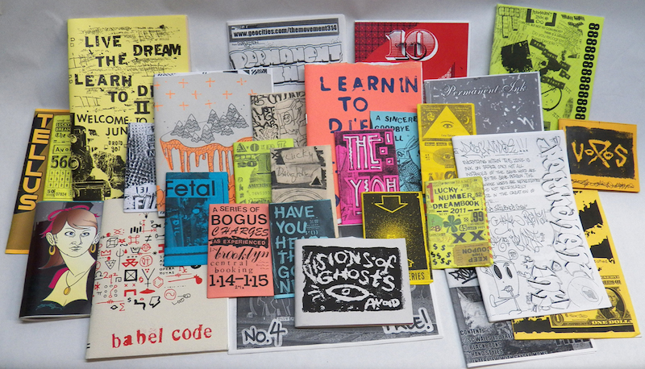
ZINES – DO IT YOURSELF

A zine (/ˈziːn/ ZEEN; an abbreviation of fanzine or magazine) is most commonly a small circulation self-published work of original or appropriated* texts and images usually reproduced via photocopier.

(*Appropriated: the use of pre-existing objects or images with little or no change applied to them)

To make your own ZINE:
Circle ONE and DESCRIBE:

- A Social or Political Issue That Effects You:

- A Story to Tell:

- An Instructional Pamphlet:

You must include:

_____At least SIX pages of TEXT and IMAGES

_____At least THREE original photographs

_____At least TWO appropriated (borrowed) images

_____At least ONE piece of found (cut/pasted) language to help convey original thoughts/writings.

