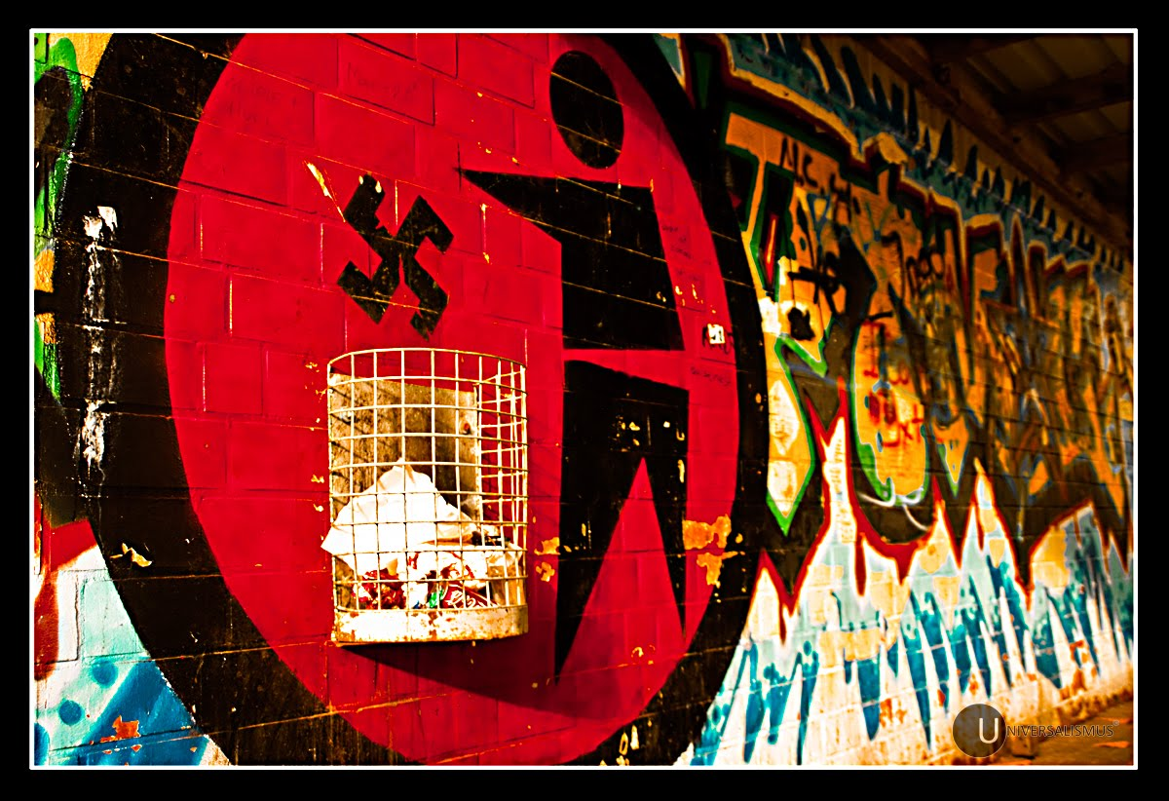
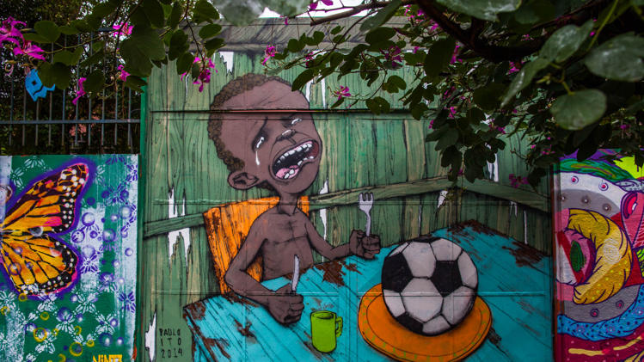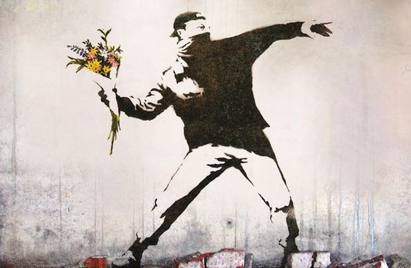

Through graffiti and street art specifically, people are able to take a creative approach at inspiring change in those around them and are able to simply and creatively bring sense to complicated situations.

We will be creating our own posters to function as public art, expressing the social issues that you wish to see change, while learning about the development of street art styles and how to create similar effects.

Choose your social/political issue:

Why is this important to you?

What do you want people to know about this topic?

How can you show this in your poster? What images or symbols will be important to include?

